**Final Report on**

WEBSITE DEVELOPMENT

(Blogging Website)

**Subject course code: CSE 326**



|  |  |  |  |  |
| --- | --- | --- | --- | --- |
| **S. No.** | **NAME** | **REG. NO.** | **ROLL NO.** | **SECTION** |
| 1. | Saurabh Kumar | 11907294 | 52 | K19VQ |
| 2. | Kshitij Kumar Sinha | 11911992 | 53 | K19VQ |
| 3. | Abhishek Gupta | 11918267 | 54 | K19VQ |

**Name of the faculty :** Moin Hassan

**Last date of submission of Project :** 10 April 2020

**Final Report**

*The project is made to bring the talented writers to the real world through virtual medium. A blog is an online journal or informational website displaying information in the reverse chronological order, with the latest posts appearing first. It is a platform where a writer or even a group of writers share their views on an individual subject.*

* **The basic objective of developing this project is:**

There are many reasons to [make a blog](https://firstsiteguide.com/start-blog/) and blog site for personal use and only a handful of strong ones for business blogging. Blogging for business, projects, or anything else that might bring you money has a very straightforward purpose – to rank your website higher in Google SERPs, a.k.a. increase your visibility.

As a business, you rely on consumers to keep buying your products and services. As a new business, you rely on blogging websites to help you get to these consumers and grab their attention. Without blogging on such platforms, your website would remain invisible, whereas running a blog and uploading it on blogging websites makes you searchable and competitive.

* **The Purpose of a Blog**

The main purpose of a blog is to connect you to the relevant audience. Another one is to boost your traffic and send quality leads to your website.

The more frequent and better your blog posts are, the higher the chances for your website to get discovered and visited by your target audience. Which means, a blog is an effective lead generation tool.

When you use your niche knowledge for creating informative and engaging posts, it builds trust with your audience. Great blogging makes your business looks more credible, which is especially important if your brand is still young and fairly unknown. It ensures presence and authority at the same time.

* **Benefits of making blogging websites**
* One single platform for connecting people
* Expressing ideas to the world
* Getting more exposure
* Refine your writing skills
* Giving and exchanging new ideas
* Great Platform for launch of a person and business
* **COMPONENTS OF THIS WEBSITE**

**In this project we are using Front end which includes HTML, CSS, Java Script**.

1. **Front end**

Front-end web development, also known as client-side development is the practice of producing HTML, CSS and JavaScript for a website or Web Application so that a user can see and interact with them directly. The challenge associated with front end development is that the tools and techniques used to create the front end of a website change constantly and so the developer needs to constantly be aware of how the field is developing.

The objective of designing a site is to ensure that when the users open up the site they see the information in a format that is easy to read and relevant. This is further complicated by the fact that users now use a large variety of devices with varying screen sizes and resolutions thus forcing the designer to take into consideration these aspects when designing the site. They need to ensure that their site comes up correctly in different browsers (cross-browser), different operating systems (cross-platform) and different devices (cross-device), which requires careful planning on the side of the developer.

1. **HTML**

Hypertext Mark up Language (HTML) is the standard [mark up language](https://en.wikipedia.org/wiki/Markup_language) for documents designed to be displayed in a [web browser](https://en.wikipedia.org/wiki/Web_browser). It can be assisted by technologies such as [Cascading Style Sheets](https://en.wikipedia.org/wiki/Cascading_Style_Sheets) (CSS) and [scripting languages](https://en.wikipedia.org/wiki/Scripting_language) such as [JavaScript](https://en.wikipedia.org/wiki/JavaScript).

[Web browsers](https://en.wikipedia.org/wiki/Web_browser) receive HTML documents from a [web server](https://en.wikipedia.org/wiki/Web_server) or from local storage and [render](https://en.wikipedia.org/wiki/Browser_engine) the documents into multimedia web pages. HTML describes the structure of a [web page](https://en.wikipedia.org/wiki/Web_page) [semantically](https://en.wikipedia.org/wiki/Semantic_Web) and originally included cues for the appearance of the document.

[HTML elements](https://en.wikipedia.org/wiki/HTML_element) are the building blocks of HTML pages. With HTML constructs, [images](https://en.wikipedia.org/wiki/HTML_element#Images_and_objects) and other objects such as [interactive forms](https://en.wikipedia.org/wiki/Fieldset) may be embedded into the rendered page. HTML provides a means to create [structured documents](https://en.wikipedia.org/wiki/Structured_document) by denoting structural [semantics](https://en.wikipedia.org/wiki/Semantics) for text such as headings, paragraphs, lists, [links](https://en.wikipedia.org/wiki/Hyperlink), quotes and other items. HTML elements are delineated by *tags* , written using [angle brackets](https://en.wikipedia.org/wiki/Bracket#Angle_brackets). Tag such as  <img /> and <input /> directly introduce content into the page. Other tags such as <p> surround and provide information about document text and may include other tags as sub-elements. Browsers do not display the HTML tags, but use them to interpret the content of the page.

HTML can embed programs written in a [scripting language](https://en.wikipedia.org/wiki/Scripting_language) such as [JavaScript](https://en.wikipedia.org/wiki/JavaScript), which affects the behaviour and content of web pages. Inclusion of CSS defines the look and layout of content. The [World Wide Web Consortium](https://en.wikipedia.org/wiki/World_Wide_Web_Consortium) (W3C), former maintainer of the HTML and current maintainer of the CSS standards, has encouraged the use of CSS over explicit presentational HTML since 1997.

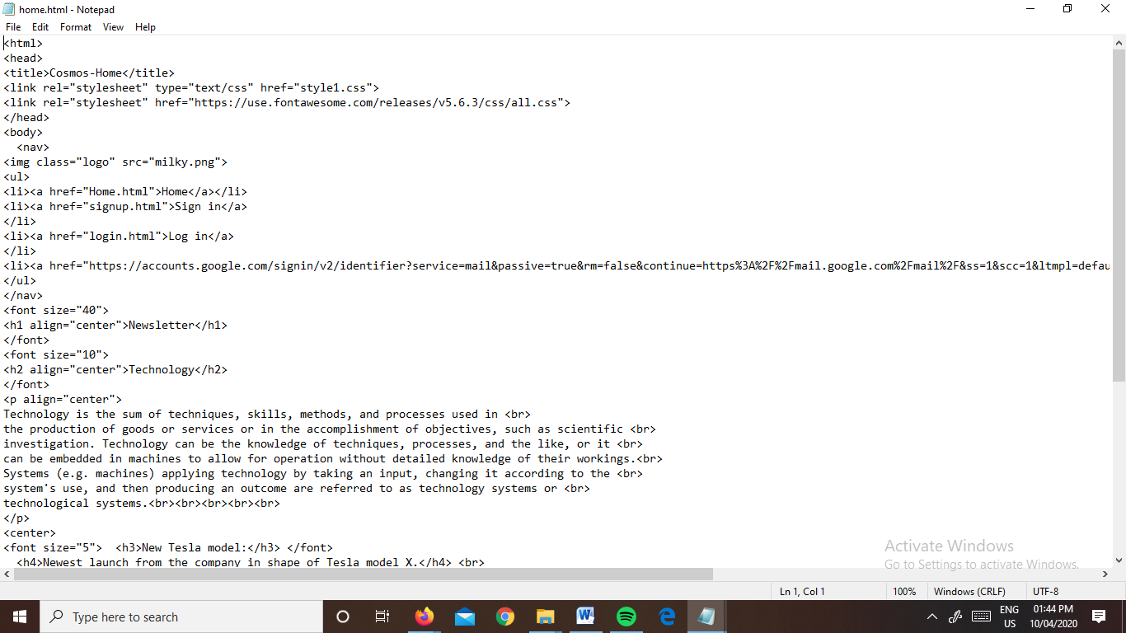

**#HTML used in our project**

1. **CSS**

**What is CSS?**

CSS stands for Cascading Style Sheets. It is a style sheet language which is used to describe the look and formatting of a document written in mark-up language. It provides an additional feature to HTML. It is generally used with HTML to change the style of web pages and user interfaces. It can also be used with any kind of XML documents including plain XML, SVG and XUL.

CSS is used along with HTML and JavaScript in most websites to create user interfaces for web applications and user interfaces for many mobile applications.

**What does CSS do?**

* We can add new looks to our old HTML documents.
* We can completely change the look of our website with only a few changes in CSS code.

**Why use CSS?**

These are the three major benefits of CSS:

1**) Solves a big problem**

Before CSS, tags like font, colour, background style, element alignments, border and size had to be repeated on every web page. This was a very long process. For example: If you are developing a large website where fonts and colour information are added on every single page, it will be become a long and expensive process. CSS was created to solve this problem. It was a W3C recommendation.

2) **Saves a lot of time**

CSS style definitions are saved in external CSS files so it is possible to change the entire website by changing just one file.

3**) Provide more attributes**

CSS provides more detailed attributes than plain HTML to define the look and feel of the website.

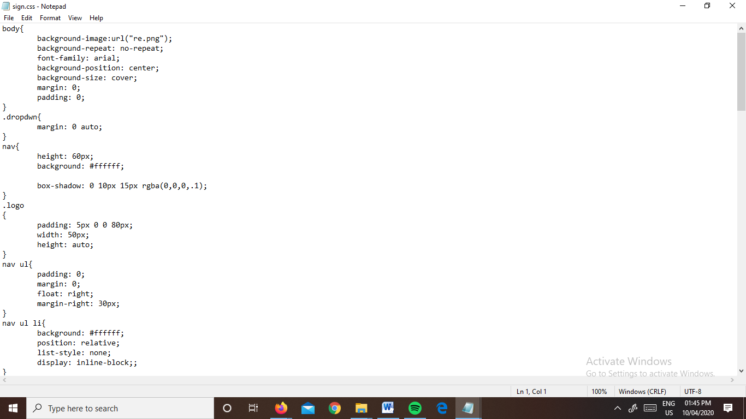

***#CSS Used in our Project***

1. **Java Script**

## What is JavaScript?

Java Script is a light-weight object-oriented programming language which is used by several websites for scripting the web pages. It is an interpreted, full-fledged programming language that enables dynamic interactivity on websites when applied to an HTML document. It was introduced in the year 1995 for adding programs to the web pages in the Netscape Navigator browser. Since then, it has been adopted by all other graphical web browsers. With JavaScript, users can build modern web applications to interact directly without reloading the page every time. The traditional website uses java script to provide several forms of interactivity and simplicity.

Although, Java Script has no connectivity with Java programming language. The name was suggested and provided in the times when Java was gaining popularity in the market. In addition to web browsers, databases such as Couch DB and Mongo DB uses Java Script as their scripting and query language.

**Features of JavaScript**

There are following features of JavaScript:

* All popular web browsers support JavaScript as they provide built-in execution environments.
* JavaScript follows the syntax and structure of the C programming language. Thus, it is a structured programming language.
* JavaScript is a weakly typed language, where certain types are implicitly cast (depending on the operation).
* JavaScript is an object-oriented programming language that uses prototypes rather than using classes for inheritance.
* It is a light-weighted and interpreted language.
* It is a case-sensitive language.
* JavaScript is supportable in several operating systems including, Windows, macOS, etc.
* It provides good control to the users over the web browsers.

**Application of JavaScript**

JavaScript is used to create interactive websites. It is mainly used for:

* Client-side validation
* Dynamic drop-down menus
* Displaying date and time
* Displaying pop-up windows and dialog boxes (like an alert dialog box, confirm dialog box and prompt dialog box)
* Displaying clocks etc.

## Conclusion

The purpose and objective of website designing is achieved. By providing extremely rich graphical user interface, webpage designing is easy and in an aesthetic form. Flexibility in designing makes user explore their imagination and thus, even a novice user can dream and accomplish their wish of web page designing.

**FINAL WEBSITE**

